PENNSYLVANIA
PUBLIC UTILITY COMMISSION
Harrisburg, PA 17105-3265

Public Meeting held September 10, 2009

Commissioners Present:

James H. Cawley, Chairman
Tyrone J. Christy, Vice Chairman
Kim Pizzingrilli
Wayne E. Gardner
Robert F. Powelson

Pennsylvania Public Utility Commission  Law Bureau Prosecutory Staff  v.  UGI Utilities, Inc. |  | M-2009-2031571

OPINION AND ORDER

BY THE COMMISSION:

Before the Commission for consideration and disposition is a Joint Settlement Agreement (Settlement) filed on July 28, 2009, by UGI Utilities, Inc. (UGI or the Company) and the Commission’s Law Bureau Prosecutory Staff (Prosecutory Staff).

History of the Proceeding

On December 9, 2006, at approximately 1:29 PM, an explosion and fire occurred at 789 Mohawk Street in Allentown, PA, destroying the structure and three adjacent row homes. There was one minor injury. The explosion occurred during the course of implementation of UGI’s automated meter reading project (AMR). UGI contracted with Itron, Inc. (Itron), which then subcontracted with Specialized Technical Services, Inc. (STS) to complete the required work in the Reading and Lehigh areas. Specifically, STS employees were to install AMR devices onto existing meters, replace incompatible meters and remove inactive meters. The explosion occurred during the course of an attempted meter removal by an STS employee. Settlement at 3.

Upon approaching the meter on the day of the explosion, the STS employee noticed that the meter was on when the work order indicated that it had been turned off. However, the employee failed to notice that the regulator indicated that the service was at medium, rather than low pressure. Despite the fact that the meter appeared to be on, he proceeded with the removal, as per his instructions. When he unscrewed the plug at the service head, gas immediately began blowing into the residence. The STS employee attempted to put the plug back in, but was unsuccessful because the pressure was approximately 57 pounds per square inch.

The STS employee evacuated the building and several adjacent buildings and, once outside, used a cell phone to call his supervisor. Shortly thereafter, the residence exploded. The resulting fire destroyed several other residences. Settlement at 4.

UGI conducted training for STS employees on November 6 through November 9, 2006 at its Reading training facility. Training included classroom presentations, hands on instruction with dummy meters and testing. Tests included both written and performance components and covered eight Operator Qualification (OQ) tasks. Among the OQ tasks tested were “Turn On and Tagging Procedures, Abandonment or Deactivation or Services (Meter Removal) and Using a Service Stopper.”

The UGI training manual indicated that service to any inside meter must be stopped prior to removal or replacement. It also stated that gas flow to a residence should be turned off at the curb valve prior to removing an inside meter. However, the STS employees received no instruction related to curb valves and the textbook did not explain how to tell the difference between medium and low pressure service to a meter. The section pertaining to inactive meter removal presupposes competency in reading pressure levels.

UGI employees and contractors were not provided with written training materials nor subjected to any exam questions that would require the ability to recognize the difference between low and medium pressure. Following the explosion, UGI changed its procedure for removing or changing an indoor meter to include the critical step of verifying the pressure of service.

UGI did not ensure that all subcontracted employees are covered by a U.S. Department of Transportation conforming drug and alcohol program and failed to inquire into the existence of STS’s program. In fact, STS employees were not covered by such a plan and were, therefore, prohibited from working on the pipeline system by both state and federal regulations.

Following the incident, the STS employee was taken for required drug and alcohol testing. Both tests results were negative, but there were sub-threshold traces of alcohol in his blood.

Discussion

Prosecutory Staff initiated an Informal Investigation of the incident to review the Company’s actions and business practices in relation to the incident. The Informal Investigation was conducted pursuant to Subsection 331(a) of the Public Utility Code (Code), 66 Pa. C.S. § 331(a), and Section 3.113 of the Commission’s Rules of Practice and Procedure (Regulations), 52 Pa. Code § 3.113.

Had this matter been litigated, Prosecutory Staff may have alleged that UGI committed the following acts or omissions in relation to this incident:

- UGI provided no written instruction in its qualification courses on how to recognize the difference between low pressure and medium pressure service lines. The qualification plan, as documented, did not include an apprenticeship or field training requirement.

If proven, the above omission would constitute a violation of 49 CFR § 192.805 (b) & (c) and 52 Pa. Code § 59.33(a).

- UGI’s written procedure for removing inactive meters at the time of the incident as it pertained to low pressure, which allowed removing the plug on an active line and inserting a stopper was inadequate.

If proven, the above omission would constitute a violation of 49 CFR § 192.751(a) and 52 PA Code § 59.33(a).

- UGI allowed a contractor to work on its gas pipeline system without ensuring that the contracting company had a DOT compliant drug and alcohol program in place.

If proven, the above omission would constitute a violation of 49 CFR §§ 199.105(a) and 199.245(b) and 52 PA Code § 59.33(a).

Settlement at 6.

After the Informal Investigation, and in accordance with 52 Pa. Code
§ 3.113(b)(3), Prosecutory Staff and UGI entered into discussions regarding settlement of the matter without the need for an on-the-record proceeding. Those discussions resulted in the instant proposed Settlement. The Parties aver that the proposed Settlement is in the public interest and request Commission approval of the Settlement. The proposed terms of the Settlement are set forth below. Pursuant to our Regulations at 52 Pa. Code § 5.231, it is the Commission’s policy to promote settlements. However, the Commission must review proposed settlements to determine whether the terms are in the public interest. Pa. PUC v. Philadelphia Gas Works, M-00031768 (January 7, 2004).

The proposed settlement includes the following terms and conditions:

- UGI has agreed, pursuant to 66 Pa.C.S. § 3301(c), to pay to the Commission, by certified check, a civil penalty in the amount of $80,000.00 within twenty (20) days of the date of the Commission’s order approving the agreement. In addition, UGI shall not claim or include any portion of this amount in any future rate proceeding.

(b) UGI will hire an outside consultant to comprehensively review and make recommended changes to UGI’s Operator Qualification meter removal tasks, standards and tests. UGI shall submit the revised tasks, standards and tests for review by the Commission’s Gas Safety Office within six (6) months of the execution of this agreement.

(c) UGI will retrain and re-qualify all required employees and contractors using the revised procedures within six (6) months of the Gas Safety Office’s approval of the revised procedures from paragraph (b) above, ensuring that the Operator Qualification tests and standards are the same for UGI employees and independent contractors.

- UGI will review and rewrite its drug and alcohol program so that UGI’s drug and alcohol rules and requirements extend to its contractors and subcontractors. Inform all employees of the revised drug and alcohol policy and require enforcement of the revised policy.

- UGI will include in the revised meter shutoff procedure the requirement (if applicable) that the curb valve be closed in addition to the meter valve, as already submitted and approved by the Gas Safety Division.

- UGI will cease and desist from committing any further violations of gas safety regulations.

Settlement at 6 - 7.

Upon our review of the terms of the Settlement, we believe that the nature of the incident and the alleged violations of federal and state gas safety regulations merit a greater penalty. Ensuring that our public utilities operate safely is of the utmost importance to us and is a task that the Legislature has entrusted to this Commission. We wish to stress that our jurisdictional public utilities must exercise care in which entities they contract with to perform work, and that we will hold them responsible for any violations caused by their contractors or sub-contractors. In this case, UGI demonstrated a lack of oversight regarding their sub-contractors’ training which resulted in a catastrophic loss of property, and the public’s safety was placed at risk on an ongoing basis. Based on our review of the incident and alleged violations, this Commission would be well within its discretion to impose a civil penalty of approximately $370,000. As we understand that it is in the public interest to settle this matter to avoid the expense of litigation, and because of the proactive remediation measures that UGI has agreed to implement in its operational and training procedures, we would instead recommend a payment of $160,000.

We also believe that the additional payment would be better utilized by directing it to UGI’s Operation Share Fuel Fund. Therefore, $80,000 would be paid as a civil penalty pursuant to 66 Pa. C.S. § 3301 and the additional $80,000 would be a contribution to Operation Share. Neither payment would be recoverable in base rates and would be in addition to any support already committed to Operation Share by UGI.

Further, we wish to strongly caution UGI and our other jurisdictional utilities that we will monitor safety violations carefully and track any trends in unsafe operational practices. We intend to fully utilize the authority given to us by the Public Utility Code and our Regulations to deter unsafe practices.

Compliance with Commission’s Policy Statement

The factors and standards for evaluating litigated and settled proceedings involving violations of the Code and the Commission’s Regulations are delineated in the Policy Statement found at 52 Pa. Code § 69.1201. We are reminded that the Policy Statement is only a guide and that the parties in settled cases should be afforded flexibility in reaching amicable resolutions to complaints and other matters so long as the settlement is in the public interest. 52 Pa. Code § 69.1201(b). The factors and standards that will be considered include the following: (1) whether the conduct and consequences of the conduct at issue were of a serious nature; (2) whether the regulated entity made efforts to modify internal practices and procedures to address the conduct at issue and prevent similar conduct in the future; (3) the number of customers affected and the duration of the violation; (4) the compliance history of the regulated entity which committed the violation; (5) whether the regulated entity cooperated with the Commission's investigation; and, (6) other relevant factors.

Since the Settlement was negotiated under the Commission’s Policy Statement, we will briefly discuss the facts of the Settlement, with our proposed modifications as discussed above, as they pertain to the Policy Statement.

The first criteria are whether the conduct and the consequences of the conduct are serious. When the conduct is of a serious nature, such as willful fraud or misrepresentation, the conduct may warrant a higher penalty. When the conduct is less egregious, such as errors in administrative filings or other technical errors, it may warrant a lower penalty. The conduct at issue is of the most serious nature as it deals with public safety. While no lives were lost in this case the potential for catastrophic loss and injury was extremely high. The corrective actions, based on our modification to the Settlement, would result in a civil penalty of $80,000 and an additional contribution to Operation Share of $80,000, which is considered significant.

Next, we examine UGI’s efforts to modify internal practices and procedures to address the conduct at issue and prevent similar conduct in the future. As a result of the December 9, 2006 explosion, UGI changed its procedure for removing or changing an indoor meter to include the critical step of verifying the pressure of service. In addition, UGI will hire an outside consultant to review and recommend changes to its Operator Qualification procedure. UGI will also re-qualify all required employees and contractors using the revised procedures.

The number of customers affected by this incident was small, but the damage to several homes was significant. Moreover, the potential for far greater damage was present.

UGI’s compliance history and cooperation with the Commission’s investigations is considered acceptable.

Before issuing a decision on the merits of the proposed Settlement, we are providing an opportunity for interested parties to file comments to the proposed Settlement as modified by this Opinion and Order; THEREFORE,

IT IS ORDERED:

1. That this Opinion and Order together with the Settlement Agreement, as modified by this Opinion and Order, shall hereby be entered for comments by any interested party.

2. That a copy of this Opinion and Order, which contains our suggested modification to the Settlement Agreement, together with the attached Settlement Agreement (which does not reflect this Commission’s modifications) shall be served on the Office of Consumer Advocate and the Office of Small Business Advocate.

3. That comments to the Settlement Agreement and this Opinion and Order will be considered timely if filed within twenty (20) days of the date of entry of this Opinion and Order.

4. That, subsequent to the Commission’s review of the comments filed in this proceeding, a final Opinion and Order will be issued.

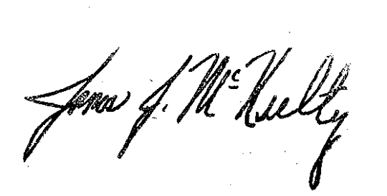
BY THE COMMISSION,

James J. McNulty
Secretary

(SEAL)

ORDER ADOPTED: September 10, 2009

ORDER ENTERED: October 1, 2009

ATTACHMENT

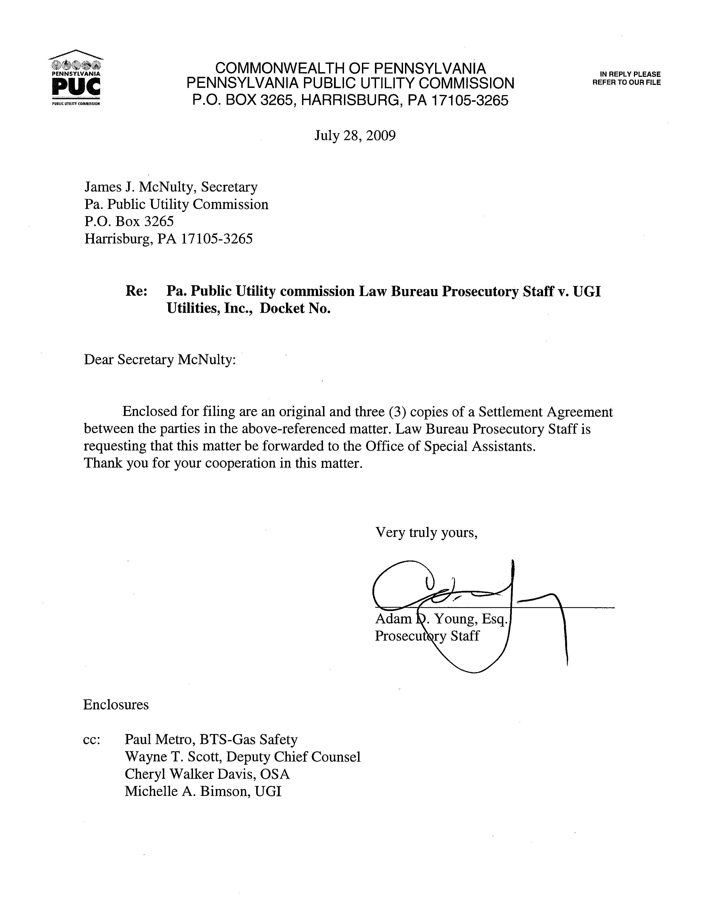

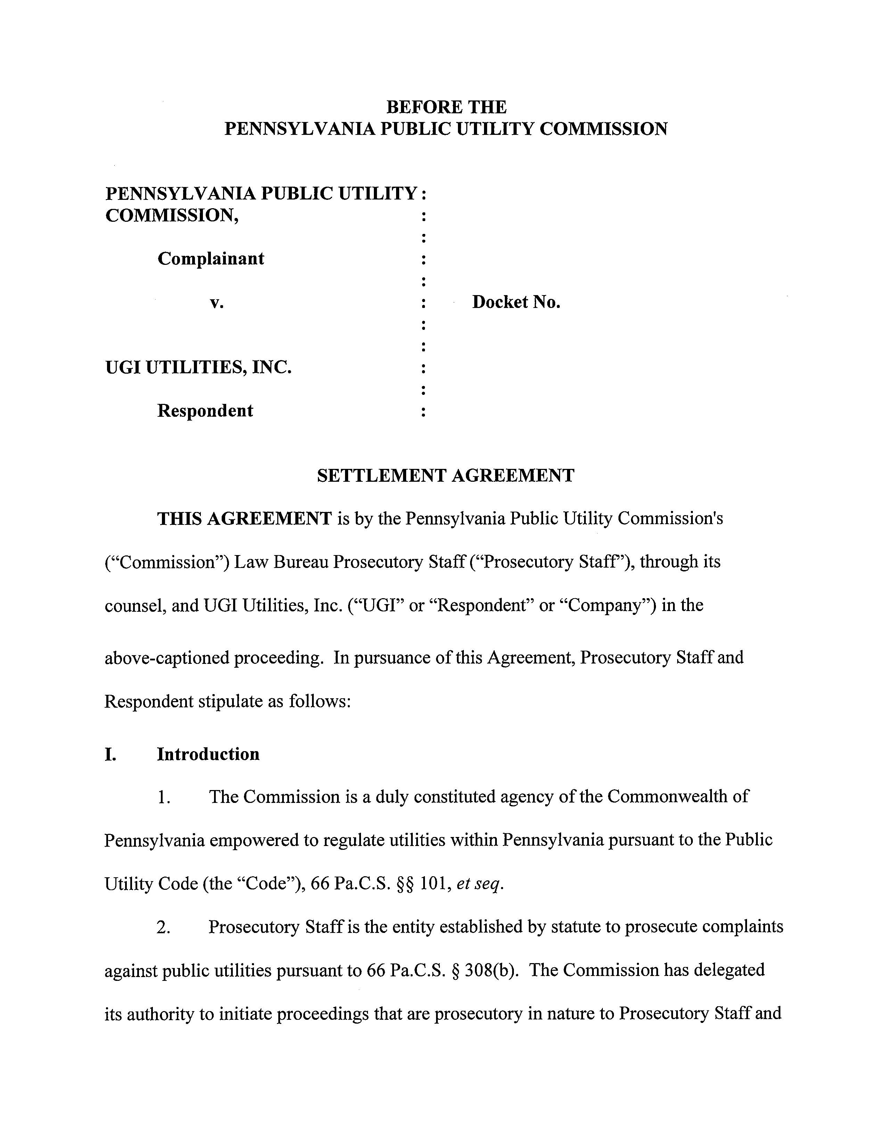

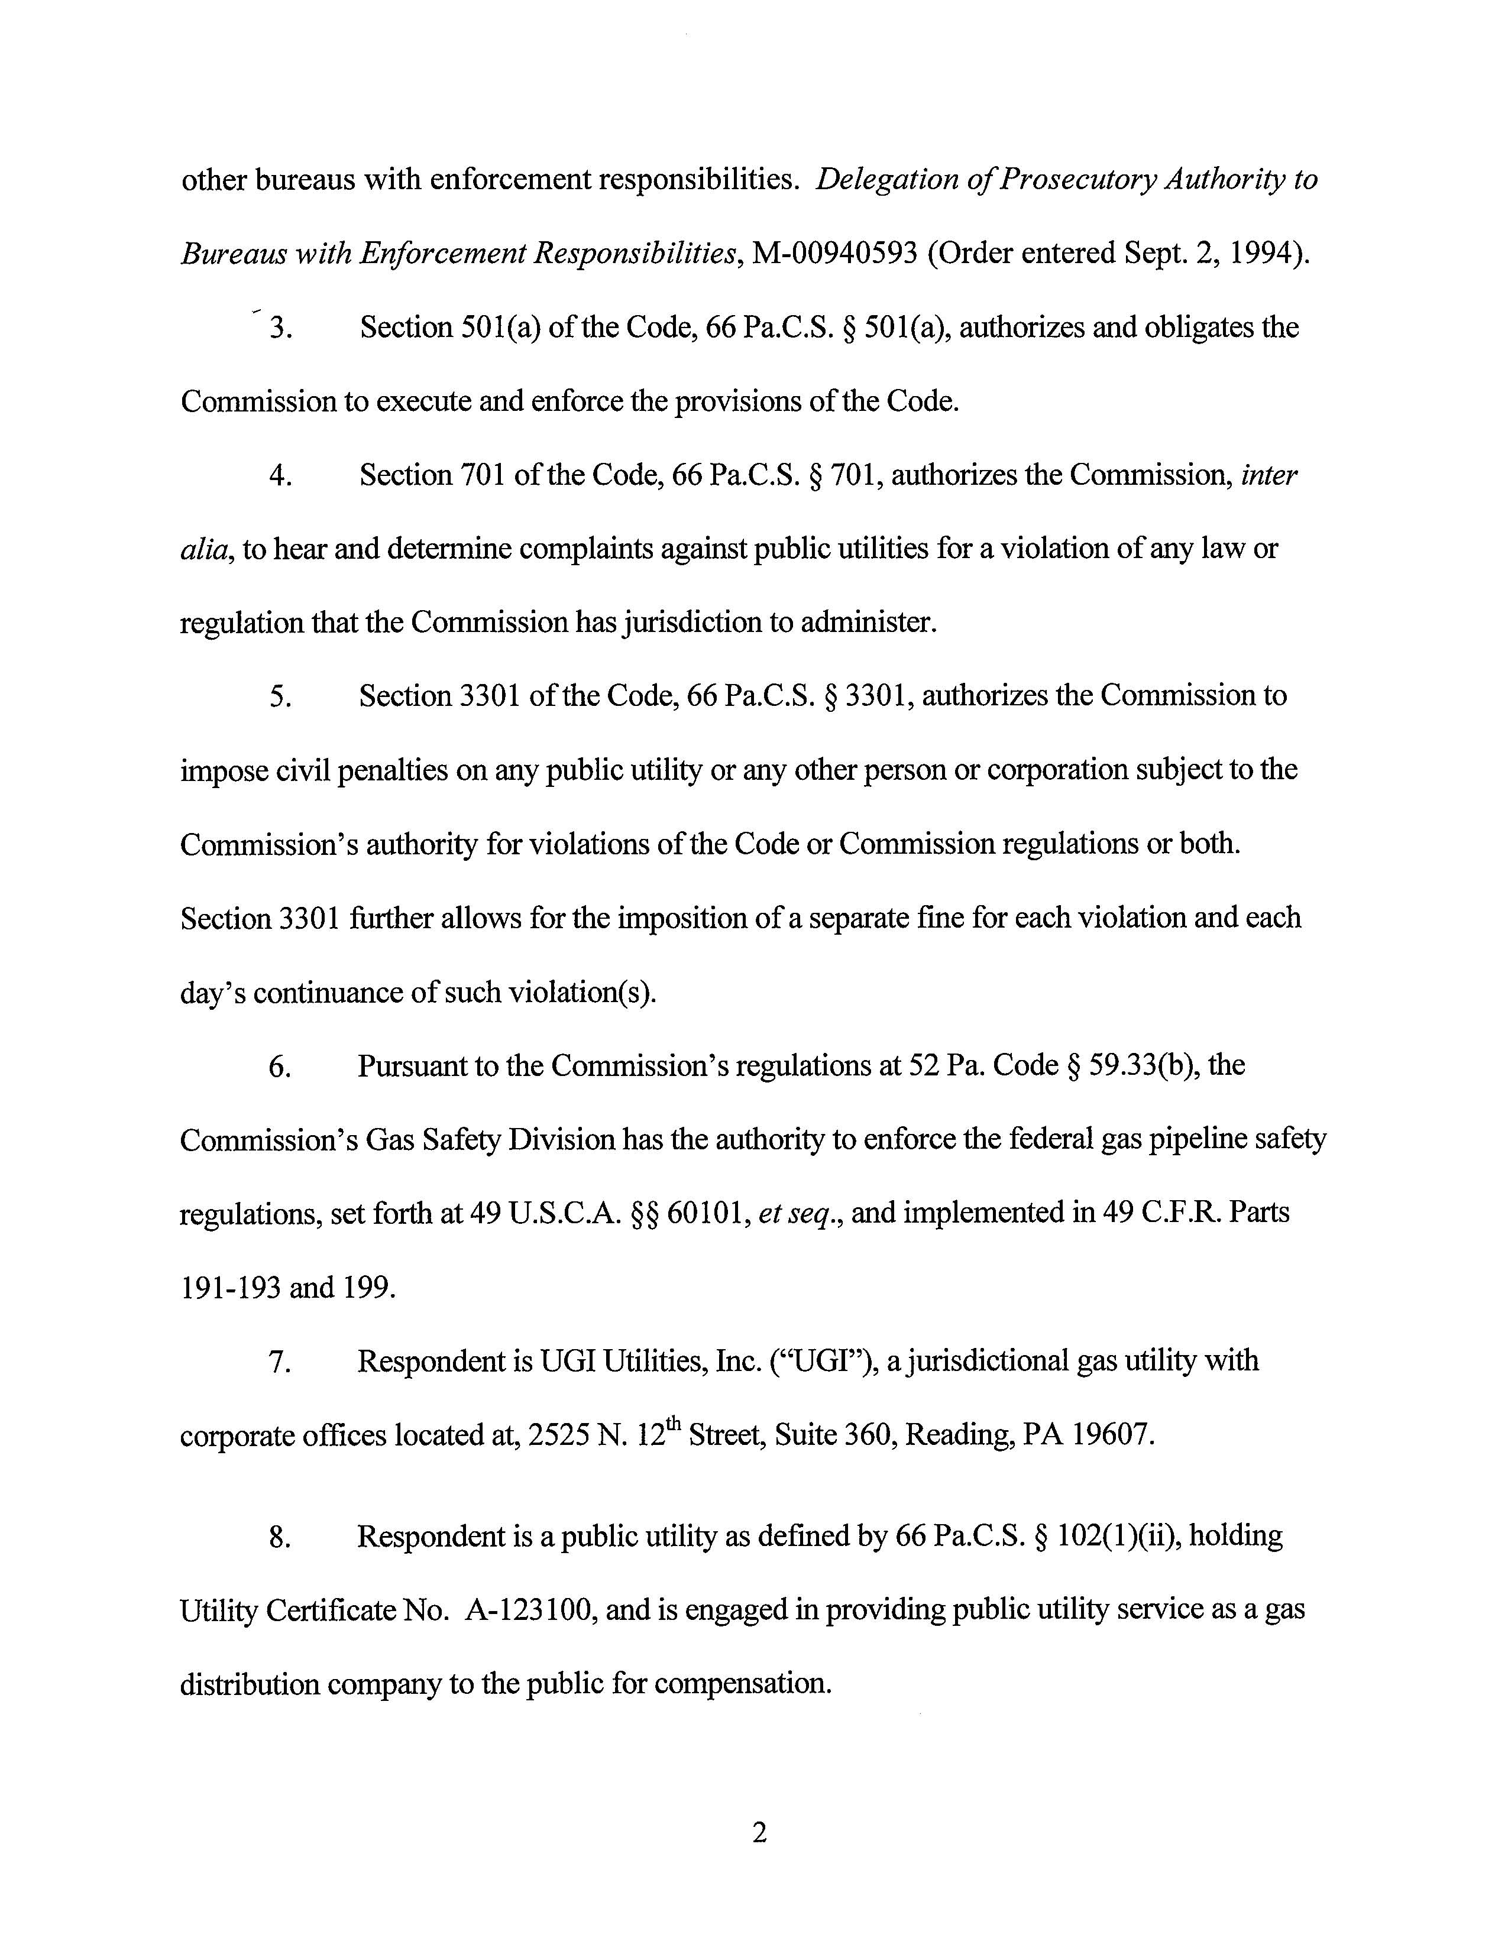

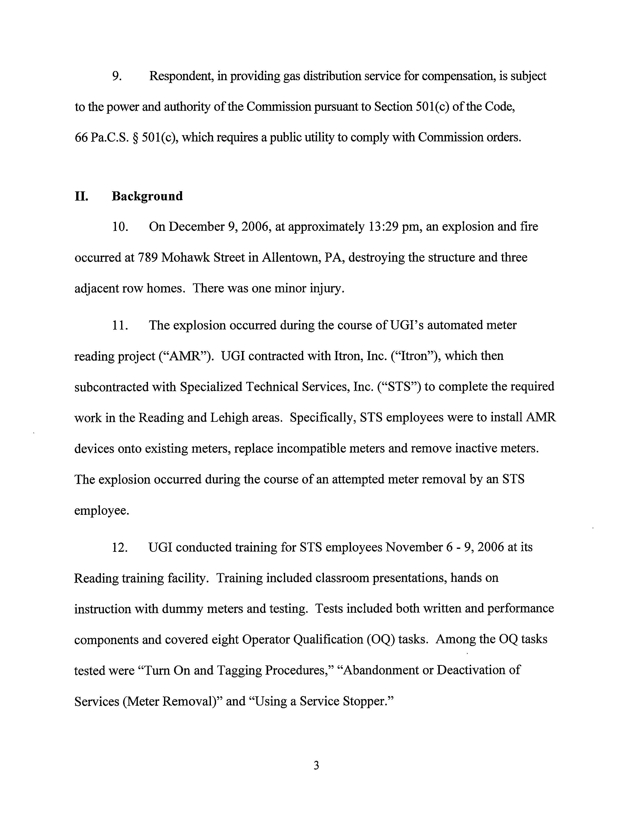

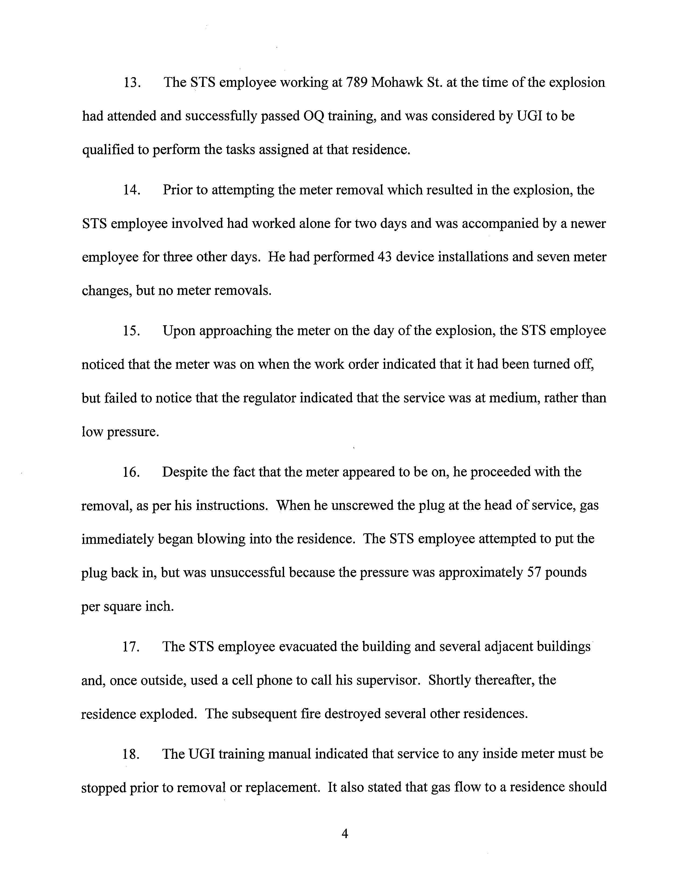

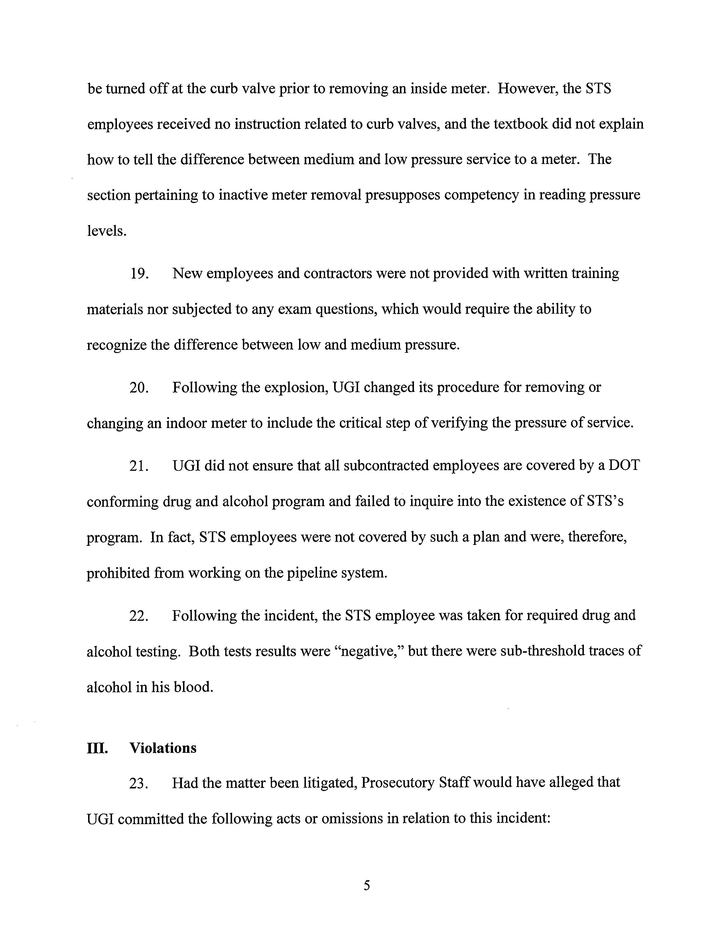

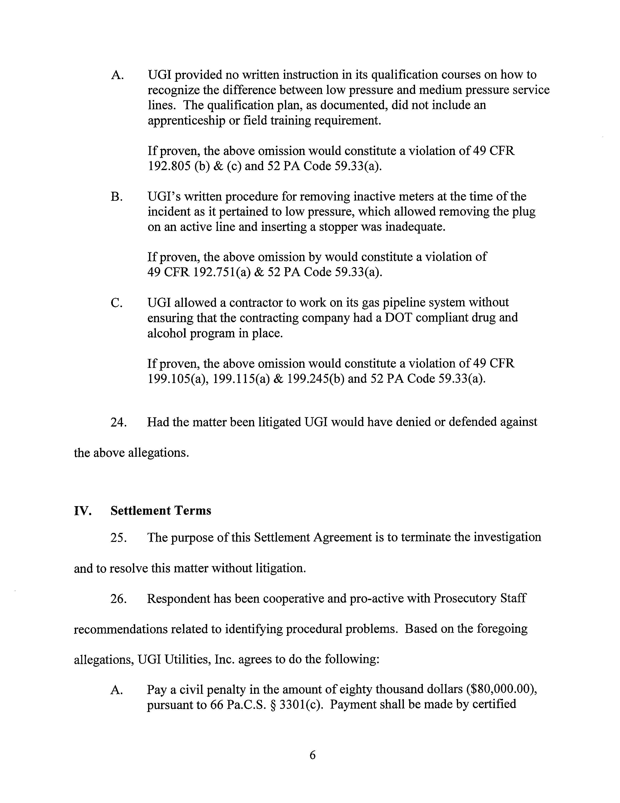

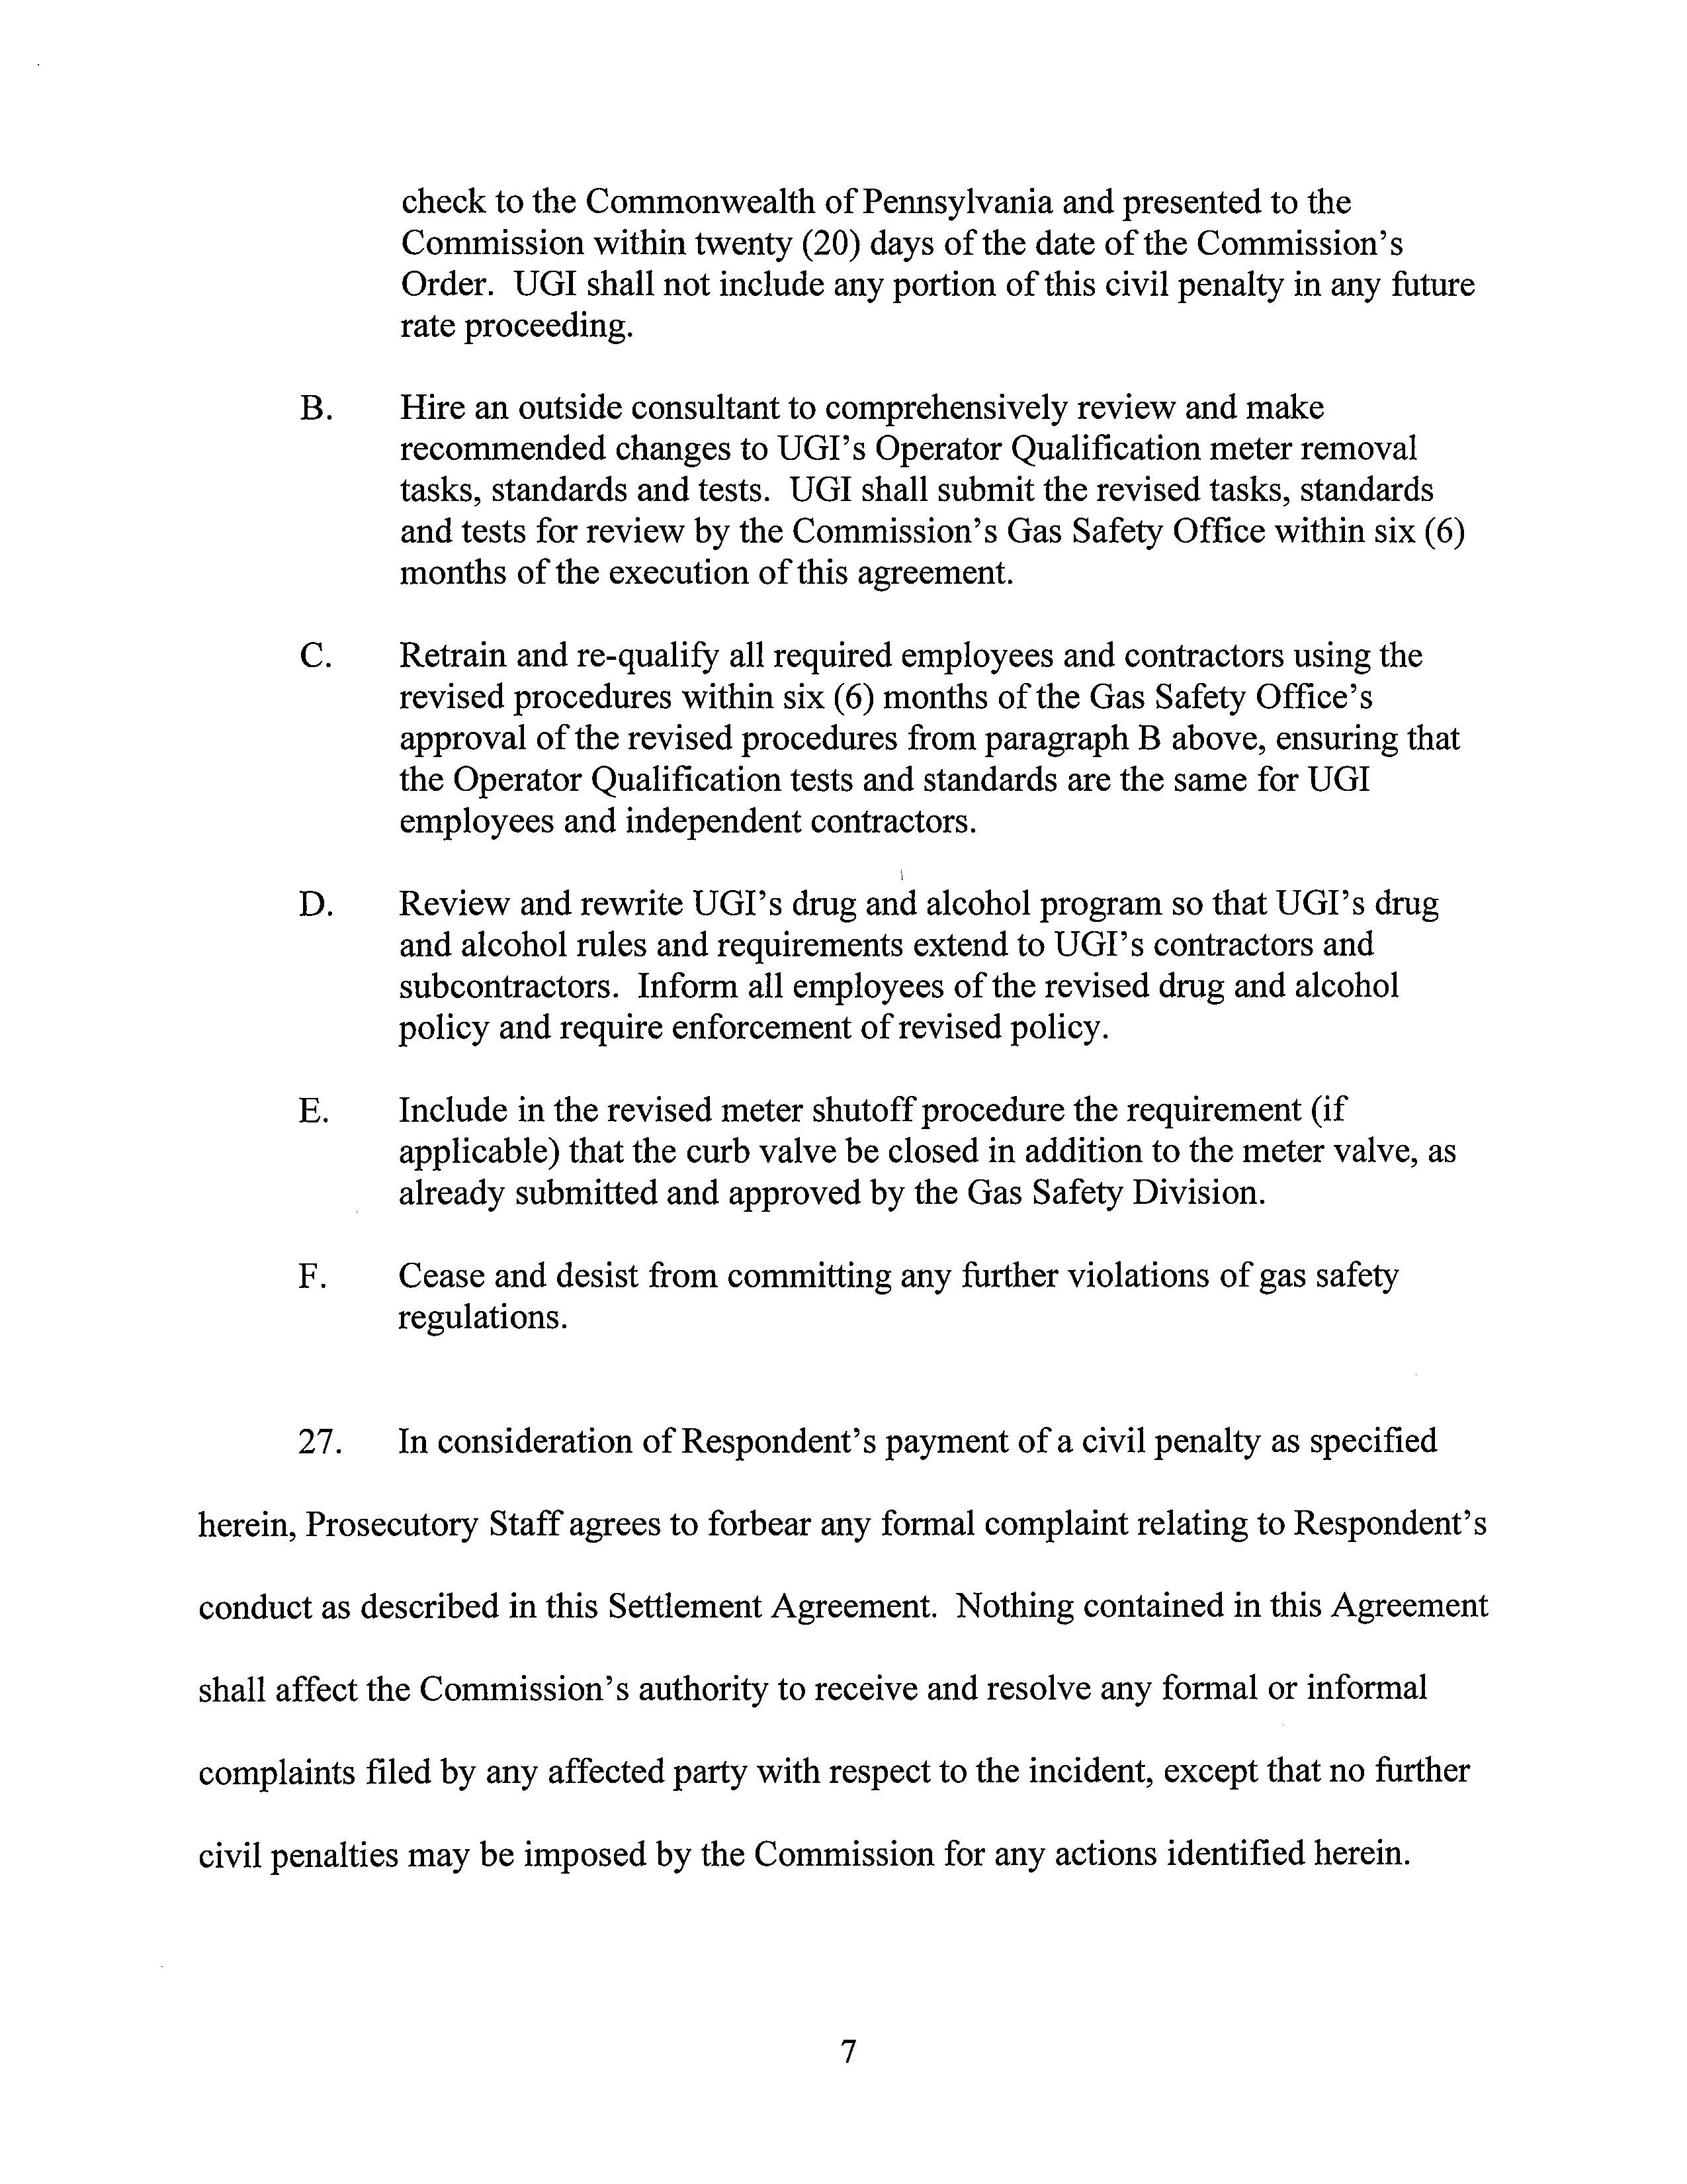

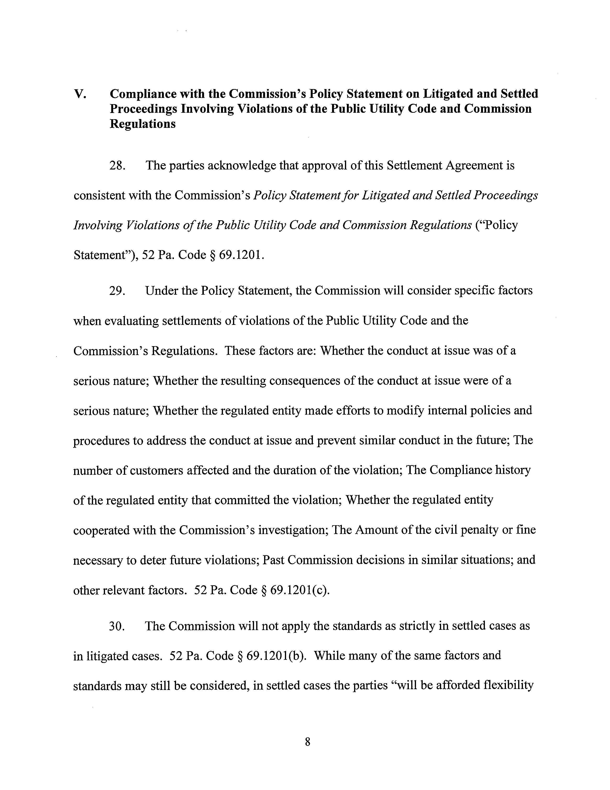

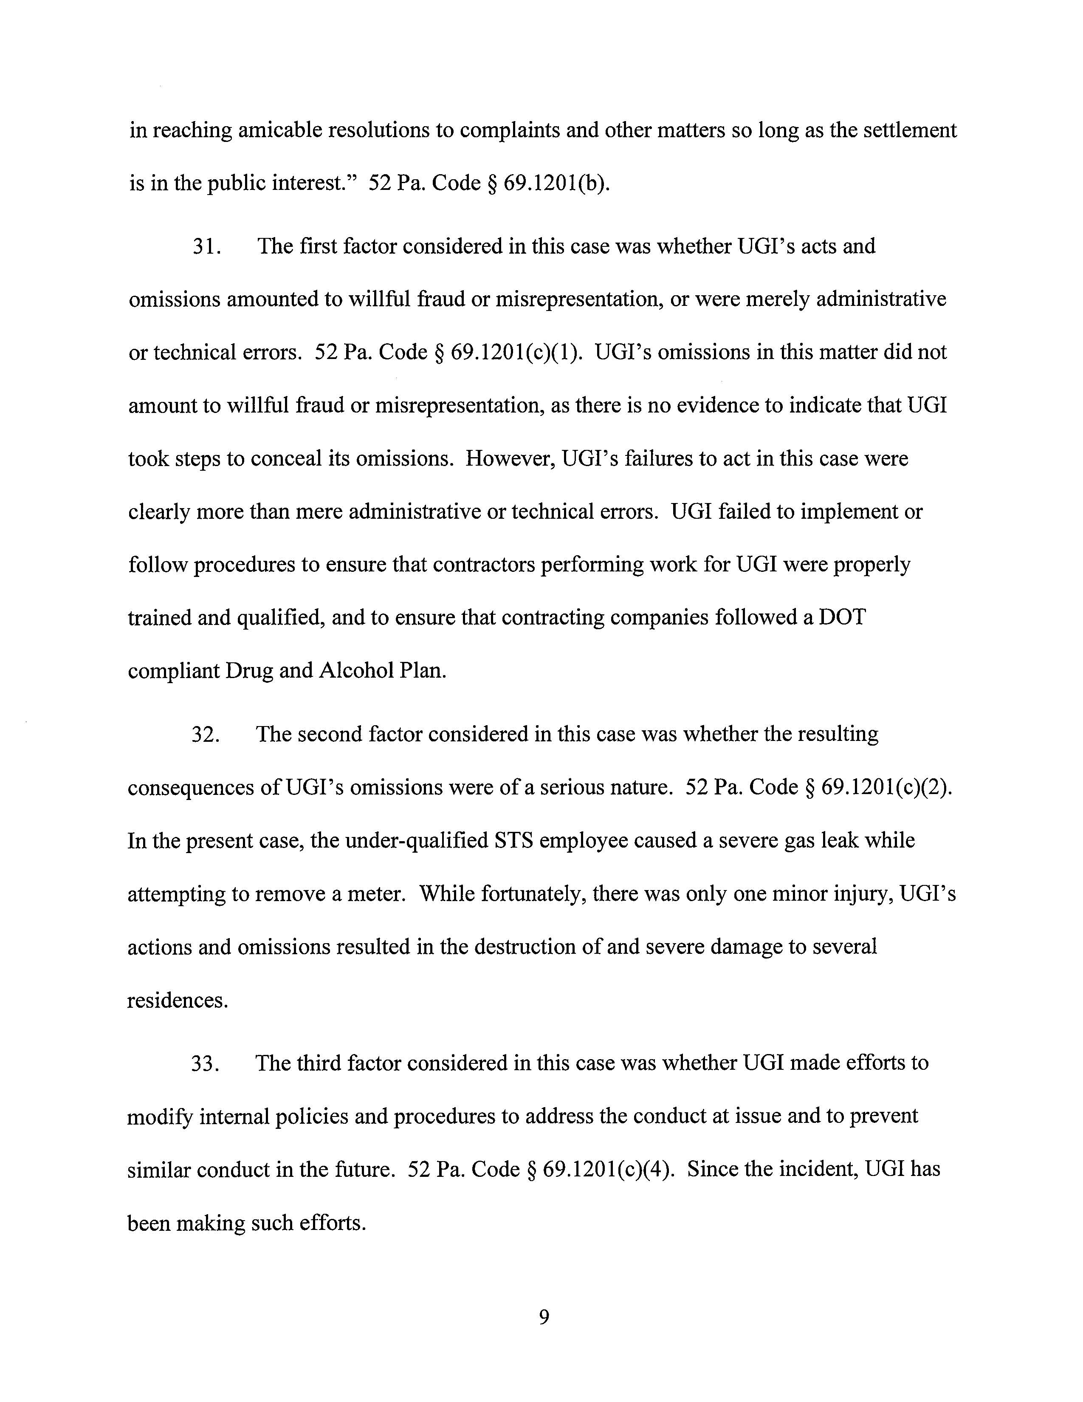

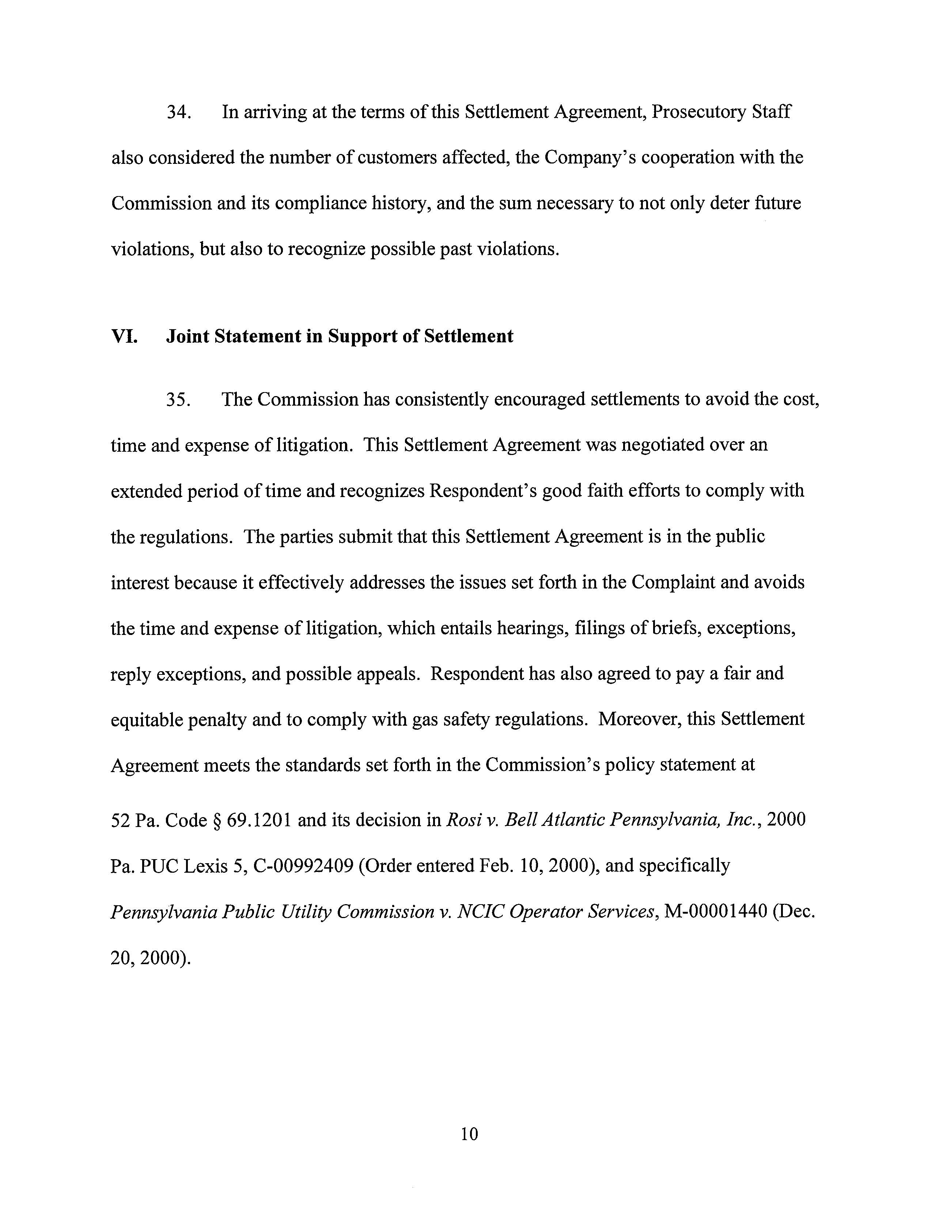

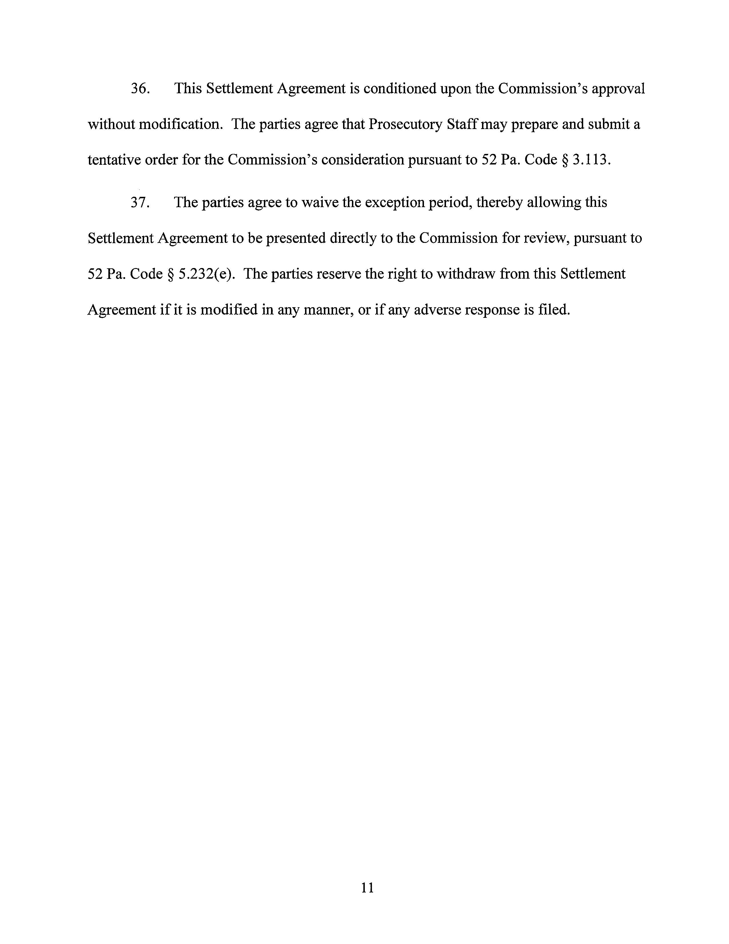

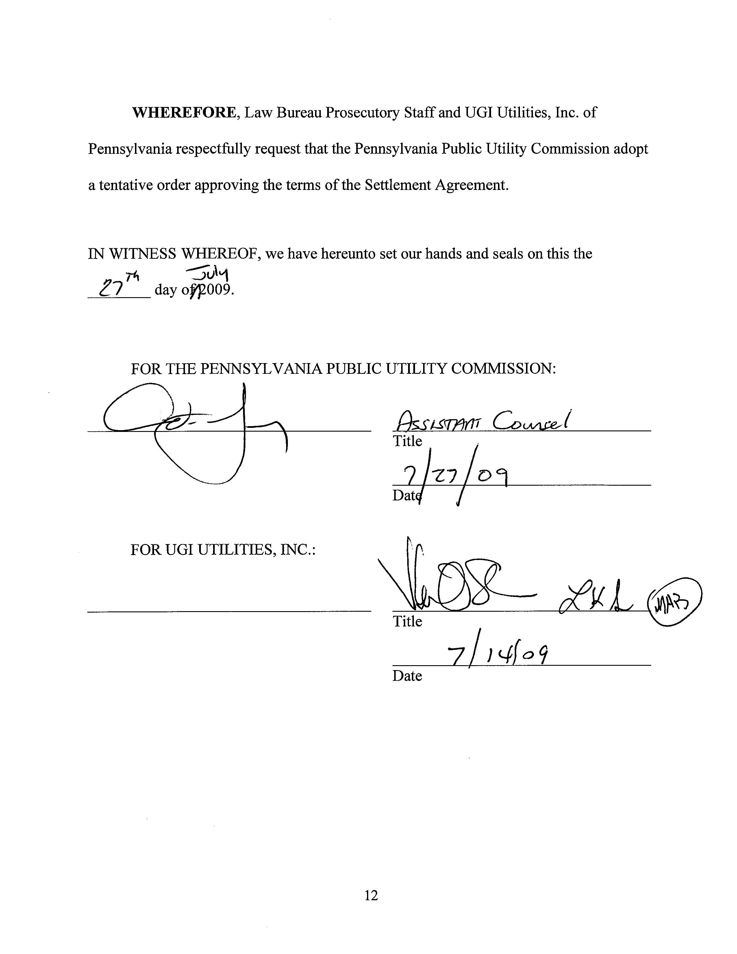

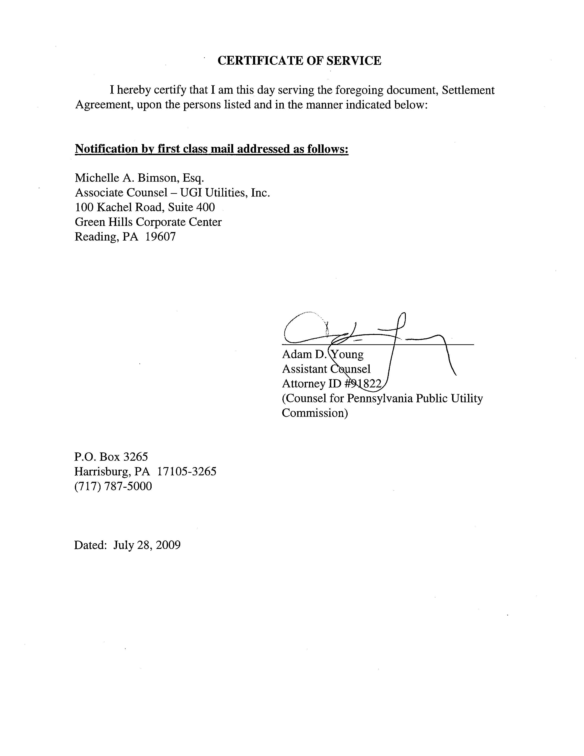

? This program helps customers who have trouble paying their winter heating bills due to problems such as low or fixed income, unemployment, disability, sudden death or serious injury/illness of the household’s main income provider.

